**ABSTRACT**

Retail inventory management is the process of ensuring you carry products that shoppers want, with neither too little nor too much on hand. By managing inventory, retailers meet customer demand without running out of stock or carrying excess supply. Inventory management is vital for retailers because the practice helps them increase profits. They are more likely to have enough inventory to capture every possible sale while avoiding overstock because Too much inventory means working capital costs, operational costs, and a complex operation. Based on the inventory management analysis we can manage how much inventory is required for selling the product based on which they can calculate the profit & losses. The objective of this project is twofold. First, it proposes an analytic model for hospital inventory management commodities, which would be able to predict the future demands of various inventory commodities. The model takes into account previous demand, population and geographic Location and other factors to successfully predict the future demand. Second, the project suggests an optimization model that would minimize the cost involved in supply chain & logistics management so that the required commodities can be made available to the hospitals at the minimum possible cost.

As inventory management deals with huge volume and different varieties of information which seems very complex to handle in the daily basis. Inventory stock should be modified or updated based on the customer retention which changes continues with the change in demand which also adds value to the organization in profits by avoiding wastages in the stock. To update the stock data in the organization one should keep on track with the end user demand time to time which can be done by keep track on goods based on First in first out and Last in First Out stock.

**INTRODUCTION**

In recent times, the employment of analytics in the all kinds of business sectors, especially the retail sector has proven to increase success in their daily operations. This project aims to prove that, in addition will identify what factors are actually contributing to this roaring success in the retail sector. Of course, the use of analytics in the business processes has its own pros and cons, but majority of the organizations feel that the introduction of analytics in their business processes has made things easier for them.

Some of the drawbacks of using big data analytics in the retail sector has risen concerns among the customers as well the retailers. Privacy concern is one of them. Customers feel that their privacy are being snatched away when retailers track their location or store their purchase information for targeting them with personalized advertisements. Although big data analytics help employees to fasten up their work, it also poses a high cost for managing such a huge amount of data. Software needed to sort and analyze these data are very expensive. On the other hand, requires skilled people to work with them. Data quality decreases because of automation of data gathering, sorting and analyzing them.

Some major advantages of using big data analytics in the retail sector are it saves costs, helps in product development, speeds up data management, helps in predicting future, helps in inventory management, helps in price management, helps in micro targeting customers, etc.

Overall, the use of analytics decreases the use of man force as it automates all the processes but on the other hand. It helps in product development as analytics can carry out sentiment analysis of a lot of actual and potential customers through social media and find out their preferred types of products, developing their future products accordingly. The use of analytics lets the retailers to predict future demands while analyzing their stocks. Micro targeting the customers can be easy when location of customers can be easily known to the retailers by the use of analytics.

Although there are many cons of adapting big data analytics in business or retail sector, but the pros are more and outweighs all the cons. This aims to prove that.

**Existing System**

Inventory data management deals with large collection stock related data in the supply chain management environment. The frequency of data collection is very high in terms of stock volume. Content analysis management plays a vital role in managing the stock data in order to classify and cluster in terms managing the data. The process of data classification and clustering will keep track on the stock in order to fulfill the customer need on demand.

The inventory management with respect to supply chain management involves not only controlling the raw materials of stock as well the cost which is related to the stock in the supply chain environment. This process involves in verifying the demand on stock by making use of the concept first in first out(FIFO) and Last in First out(LIFO) techniques in order to verify the demand basis of end user which helps to control the wastages in stock in inventory Management.

The error rate and complexity of huge volume of data is very high. We need some techniques in order to prevent the issues which are directly related to the volume and variety of data in managing the stock information within an organization.

In this approach, supply chain management and inventory data management deals the huge assortment of data in terms of both volume and variety using different dimensions.

1. Data Classification

2. Data clustering

3. Content analysis

4. Customer retention

5. Inventory based on LIFO and FIFO.

Supply chain Management and inventory data management using big data analytics In inventory management, we support to marketing analysis which helps in identifying the stock with in demand with respect to the end user with the change in need. Based on this survey, we can update the stock management with respect to the time and situation of the end user. Analysis of data prediction is based on customer retention which directly related to the end user satisfaction rate.

The increase in data results not only in storage but also in analyzing and processing the flow of information in while classifying and clustering the data as per need. There we come up with a concept of content analysis and management which is major aspect in managing the stock within an organization with raised change in demand.

**Disadvantages of Existing System**:

* As inventory management has numerous components, clear communication is vital for a seamless flow.
* Better access would improve the efficiency of inventory and other business processes.
* Warehouse management would be vulnerable to errors without integrated software. Inept warehouse management could lead to lost orders, delays in order fulfillment, and errors in shipment.
* Selling more than you can deliver could stain your business’ reputation for a long time.

**Proposed System**

Empirical research has provided clear evidence of the existence of inventory record inaccuracy in a number of contexts, including government agencies (Schrady 1970 and Rinehart 1960) and utilities (Redman 1995). In the retail context that is our focus, Gentry (2005) reports a discrepancy between recorded and actual inventory amounting to $142 million, or the equivalent of 21,000 ocean containers, at The Limited, a well-known apparel retailer. DeHoratius and Raman (2004) measure inventory record inaccuracy at Gamma. Ton and Raman (2005) examine the problem of misplaced products at Borders.

Both papers identify several drivers of such execution problems and discuss their impact on retail product availability. The working paper of Lee and Ozer (2005) provides a recent summary of modeling research on inventory record inaccuracy. Modeling work on the issue of record inaccuracy dates to Iglehart and Morey (1972), who derive approximations of audit policies and buffer stocks that limit the probability of physical inventory stockouts. Morey (1985) provides a “back of the envelope” expression for service levels in terms of buffer stock and audit frequency. Morey and Dittman (1986) analyze the problem of selecting audit frequencies to achieve desired inventory record accuracy goals.

More recently, Camdereli and Swaminathan (2005) examine supply chain coordination issues when the retailer must contend with inventory record inaccuracy. Focusing on the problem within a firm, Kang and Gershwin (2005) evaluate the potential cost of record inaccuracy using a simulation study and evaluate several simple heuristic remedies. Kok 5 and Shang (2005) examine policies for triggering inventory audits in a system where excess demand is backlogged.

The backlogging assumption decomposes the accumulation of inventory record discrepancy from inventory levels, and they study a dynamic programming formulation where the number of days since the last audit serves as a sufficient statistic for the distribution of record error. Lee and Ozer’s (2005) survey reports on some original research into replenishment policies in which multiple sources of record inaccuracy (i.e., misplacement, shrinkage, and transaction errors) are modeled explicitly.

We note that in deriving policies for the lost sales case with unobserved errors, they ultimately make a simplifying assumption that record errors grow irrespective of inventory levels, thus allowing them use a sufficient statistic for the distribution of record error similar to that used by Kok and Shang (2005). We assume a single source of inventory record inaccuracy modeled by a single, unsigned random disturbance each period. Such a model allows us to explicitly account for the interaction between inventory inaccuracy and sales observations in a lost sales environment. Our contributions are a model of a lost sales retail inventory system with record inaccuracies, the derivation of a Bayesian inventory record in such a system, and policies based on the Bayesian inventory record for both replenishment and audit triggering.

Furthermore, we emphasize the practicality of our proposed methods by demonstrating the estimation of necessary parameters using data from a real retailer. Bensoussan, Cakanyildirim, and Sethi (2005) provide some technical results on Bayesian updating and replenishment in an inventory system in which the inventory manager observes only whether physical inventory levels are zero or nonzero.

We note that Bayesian approaches have arisen elsewhere in the inventory management literature, most notably when the inventory manager’s uncertainty is not about the inventory position but rather about some aspect of the demand distribution.

**Illustrations on the System**

**Use Case**

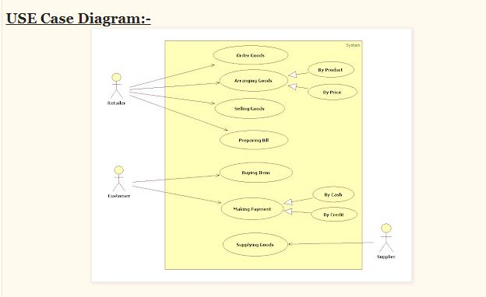

**Class Diagram**

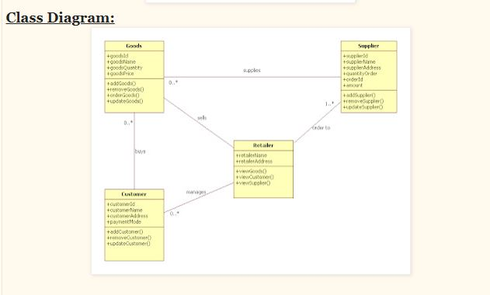

**Statechart Diagram**

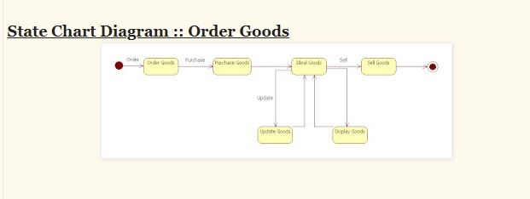

**Sequence Diagram**

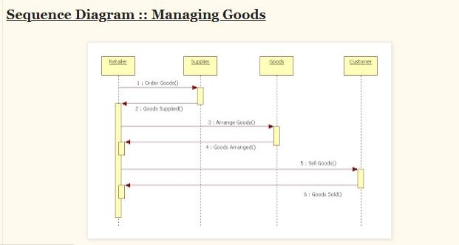

**Conclusion:-**

In the past years, the efficiency of inventory management has become an area of major concern in business. New inventory models for managing the inventory levels are now available. Most of the analytical models addressed only one type of uncertainty and assumed a simple structure of the production process. The most common dimensions to be considered as fuzzy variables are demand, the cost of acquisition. Each model, based on some assumptions, has its benefits and disadvantages, but still, many authors continue to design inventory control models using such approach as fuzzy logic.

The existence of such quantity of models shows that fuzzy set theory is one of the appropriate methods, which can suppose a great advance in inventory management. The emphasis in each review was to identify how the fuzzy set theory was used in the formulation of the inventory model. The classification and review of models are quite general and can be extended.

**REFERENCES**

1. Retail Inventory Management When Records Are Inaccurate Nicole DeHoratius, Adam J. Mersereau, and Linus Schrage The University of Chicago Graduate School of Business 5807 South Woodlawn Ave., Chicago, IL 60637 @ChicagoGSB.edu November 10, 2005.
2. Inventory Record Inaccuracy: An Empirical Analysis Nicole DeHoratius1 and Ananth Raman2 August 2004.
3. Retail Inventory Management with stock-out based dynamic demand substitution : Baris Tan n , Selcuk Karabati College of Administrative Sciences and Economics, Koc- University, Rumeli Feneri Yolu, Sariyer, 34450 Istanbul, Turkey.
4. Inventory Management of a Fast-Fashion Retail Network : Felipe Caro J´er´emie Gallien † August 2, 2007.
5. A Review of Inventory Management Research In Major Logistics Journals Themes and Future Directions : Brent D. Williams Department of Marketing and Logistics, Sam M. Walton College of Business, University of Arkansas, Fayetteville, Arkansas, USA, and Travis Tokar The Ohio State University, Fisher College of Business, Marketing and Logistics, Columbus, Ohio, USA
6. Inventory management in retail industry - Application of big data analytics : Hien Vu – ID: 869211121
7. Predictive Analysis of Big Data in Retail Industry Literature Review Hamza Belrari1, Abdelali Tajmouti1 1 lmeet, FST of Settat, Hassan 1st University Settat, Morocco hamzabelarbi@gmail.com Hamid Bennis , Mohammed el haj tirari 2 lmeet, FPK/FST of Settat, Hassan 1st University Settat, Morocco 3 INSEA, Rabat, Morocco.
8. A Model Proposal for Big Data Analytics in the Retail Sector of Bangladesh : Ahmed Imran Kabir*, Faiza Tabassum, Jakowan and Rifat Afrin, School of Business and Economics, United International University, Bangladesh ,Copyright @ 2021.
9. Contemporary Supply Chain and Inventory Data Management Using Data Analytics : Dr. S. Sai Satyanarayana Reddy, Ch. Mamatha, Priyadarshini Chatterjee and S Nagarjuna Reddy Department of Computer Science and Engineering; Department of Information Technology, Vardhaman College of Engineering, Hyderabad, India.
10. Optimal Health Care Inventory Management Using Analytics Neeraj Agrawal Prakarsh Paritosh Ashish Paralikar Dibyajyoti Pati General Electric JFWTC, 122 EPIP Bangalore, India 560066.
11. Lin, D.C., and Yao, J.S. (2000). Fuzzy Economic Production for Production Inventory. Fuzzy Sets and Systems, 111(3): 465–495.
12. Wagner, H.M. (1980). Research Portfolio for Inventory Management and Production Planning Systems. Operation Research, 28(3): 445–475.